Form of Bank Guarantee

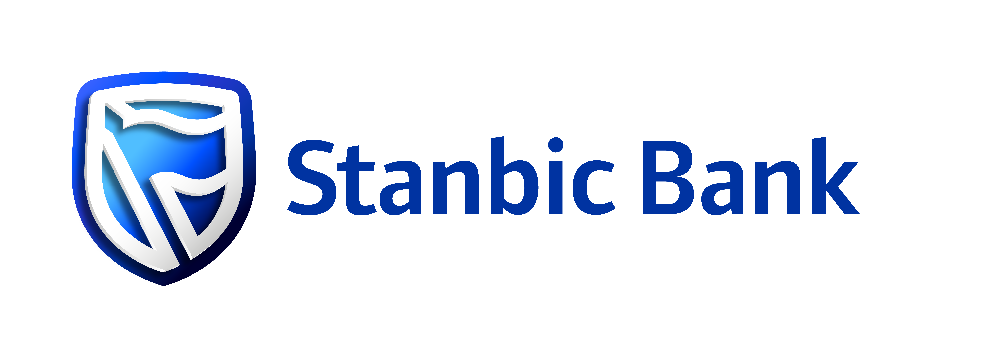

WE DRAW YOUR ATTENTION TO THE FACT THAT THIS IS A DRAFT FORMAT OF A TRADE INSTRUMENT (THE “DRAFT”) ONLY. THIS DRAFT IS SUPPLIED, WITHOUT ANY LIABILITY ON OUR PART, SOLELY IN ORDER TO ASSIST YOU IN YOUR NEGOTIATIONS. THIS DRAFT RELATES TO THE PARTICULAR CIRCUMSTANCES YOU OUTLINED TO US AND SHOULD, THEREFORE, NOT BE EMPLOYED AS A GENERAL PRECEDENT. STANBIC BANK KENYA LIMITED WILL NOT BE LIABLE TO HONOUR ANY DOCUMENTARY PRESENTATION MADE, OR ANY CLAIM FOR PAYMENT RECEIVED, UNDER THIS DRAFT. THIS DRAFT SHALL NOT BE DEEMED TO CREATE A COURSE OF DEALING OR OTHERWISE OBLIGATE STANBIC BANK KENYA LIMITED TO ISSUE A FINAL TRADE INSTRUMENT IN THE FORMAT ADVISED. STANBIC BANK KENYA LIMITED RESERVES THE RIGHT (BUT NOT THE OBLIGATION) TO ISSUE A FINAL TRADE INSTRUMENT

Irrevocable Bank Guarantee (IBG)
.
REF:
.
DATE:
.
THE DIRECTORS,
[BENEFICIARY NAME]
[BENEFICIARY ADDRESS],
NAIROBI KENYA
.
DEAR SIRS,
.
[BENEFICIARY NAME] INITIAL PUBLIC OFFER (IPO) 2026 IRREVOCABLE BANK GUARANTEE IN RESPECT OF PAYMENT FOR ALLOCATION OF NEW SHARES {INSERT NAME OF THE INVESTOR}
.
WHEREAS [NAME OF INVESTOR] [THE “INVESTOR”] HAS BY AN APPLICATION, SERIAL NUMBER [INSERT SERIAL NUMBER], DATED [INSERT DATE] APPLIED FOR [INSERT THE NUMBER OF SHARES] NEW SHARES IN [BENEFICIARY NAME] IPO (“APPLICANT NAME IPO”) 2026 AS SET OUT IN THE INFORMATION MEMORANDUM (“IM”) DATED DD MM, 2026.
.
AND WHEREAS IT HAS BEEN STIPULATED IN THE [APPLICANT NAME] IPO IM THAT THE INVESTOR SHALL FURNISH YOU WITH AN IRREVOCABLE ON DEMAND GUARANTEE FOR THE FULL VALUE PAYABLE FOR THE NEW SHARES APPLIED FOR AT THE OFFER PRICE.
.
AND WHEREAS WE [NAME OF GUARANTOR] HAVE AGREED TO GIVE THIS BANK GUARANTEE AND REPRESENT AND WARRANT THAT WE HAVE FULL POWER, AUTHORITY, AND LEGAL CAPACITY TO ENTER INTO AND PERFORM THIS GUARANTEE, THAT THIS GUARANTEE CONSTITUTES ITS LEGAL, VALID, AND BINDING OBLIGATIONS ENFORCEABLE AGAINST IT IN ACCORDANCE WITH ITS TERMS, THAT THE EXECUTION AND PERFORMANCE OF THIS GUARANTEE DO NOT VIOLATE ANY APPLICABLE LAW OR ANY CONTRACTUAL RESTRICTION BINDING UPON IT, AND THAT ALL INFORMATION PROVIDED BY THE GUARANTOR IN CONNECTION WITH THIS GUARANTEE IS TRUE, ACCURATE, AND COMPLETE IN ALL MATERIAL RESPECTS.
.
NOW, AT THE REQUEST OF THE INVESTOR AND IN CONSIDERATION OF YOUR ALLOCATION TO THE INVESTOR THE NEW SHARES, OR SUCH LESSER NUMBER AS YOU SHALL IN YOUR ABSOLUTE DISCRETION DETERMINE, WE HEREBY IRREVOCABLY AND UNCONDITIONALLY UNDERTAKE, AS PRIMARY OBLIGOR, TO PAY YOU IN KENYA SHILLINGS, UPON RECEIPT OF THIS ORIGINAL GUARANTEE AND YOUR FIRST WRITTEN DEMAND THROUGH STANBIC BANK KENYA LIMITED IN FULL WITHOUT SET OFF OR COUNTER CLAIM AND FREE FROM ANY DEDUCTION OR WITHHOLDING WHATSOEVER, SUCH SUM AS MAY BE DEMANDED BY YOU UP TO A MAXIMUM SUM OF KENYA SHILLINGS ([WORDS][ FIGURES]) WITHOUT YOUR NEEDING TO PROVE OR TO SHOW GROUNDS OR REASONS FOR YOUR DEMAND OR THE SUM SPECIFIED THEREIN.
.
PROVIDED ALWAYS THAT THIS GUARANTEE IS STRICTLY LIMITED TO THE OFFER PRICE FOR THE NEW SHARES AND EXPRESSLY EXCLUDES ANY FEES, COSTS, COMMISSIONS, LEVIES, EXPENSES, TAXES, DUTIES, INTEREST, DEFAULT INTEREST, PENALTIES, OR SIMILAR AMOUNTS, NONE OF WHICH SHALL BE RECOVERABLE FROM THE GUARANTOR UNDER THIS UNDERTAKING. THIS GUARANTEE SHALL NOT BE DISCHARGED, RELEASED, OR OTHERWISE AFFECTED BY ANY AMENDMENT, SUPPLEMENT, OR

WAIVER OF THE TERMS OF THE IPO OR THE INFORMATION MEMORANDUM, ANY EXTENSION OF TIME, INDULGENCE, OR CONCESSION GRANTED BY THE ISSUER, THE INSOLVENCY, RESTRUCTURING, OR DISSOLUTION OF ANY OTHER PERSON, OR ANY OTHER ACT, OMISSION, MATTER, OR CIRCUMSTANCE WHICH MIGHT OTHERWISE OPERATE TO DISCHARGE OR EXONERATE A GUARANTOR.
.
THIS GUARANTEE WILL REMAIN IN FORCE UP TO AND INCLUDING 5:00 P.M. ON [INSERT LAST DATE OF PAYMENT FOR IBG] AND IS SUBJECT TO THE UNIFORM RULES FOR DEMAND GUARANTEES (URDG) 2010 REVISION, ICC PUBLICATION NO.758 AND SHALL BE GOVERNED AND CONSTRUED IN ACCORDANCE WITH THE LAWS OF THE REPUBLIC OF KENYA. THE COURTS OF THE REPUBLIC OF KENYA SHALL HAVE EXCLUSIVE JURISDICTION TO SETTLE ANY DISPUTE ARISING OUT OF OR IN CONNECTION WITH IT.
.
THIS IBG CONSTITUTES THE ENTIRE AGREEMENT BETWEEN THE PARTIES, NO AMENDMENT TO IT SHALL BE EFFECTIVE UNLESS MADE IN WRITING AND SIGNED BY ALL PARTIES
.
IN WITNESS WHEREOF THIS LETTER OF IRREVOCABLE BANK GUARANTEE HAS BEEN EXECUTED BY US ON THIS
.
[DATE ON OR BEFORE [DATE].
.
[SIGNED AS PER THE GUARANTOR]

